Michele Speidel

8/14/2022

Module 1.2 Assignment

GitHub Repository Setup

CSD340-330H_2231_DD

Wev Development with HTML and CSS

Professor Sue Sampson

1. Link to GitHub Repository

<https://github.com/jamdmmsfreese/csd-340>

1. Screenshot of GitHub Repository

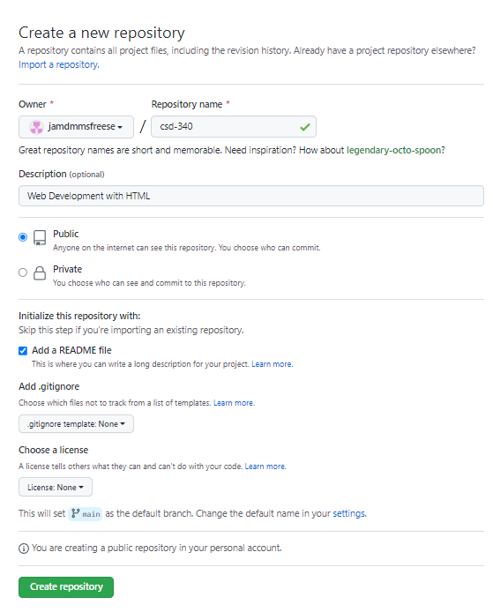

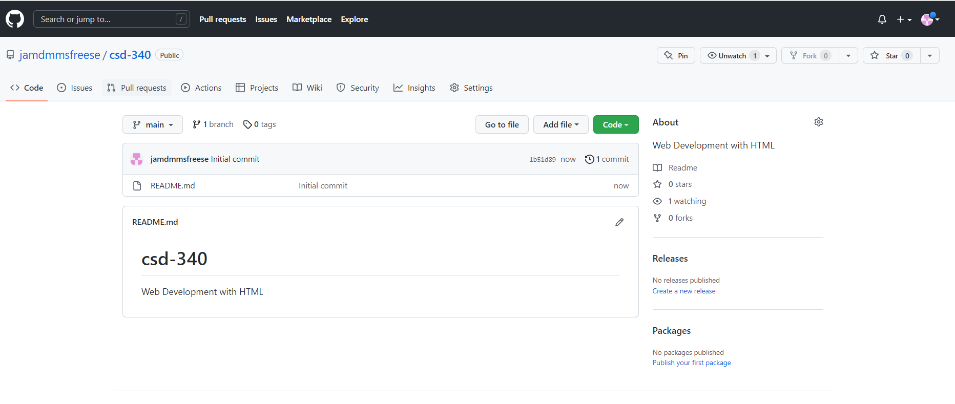

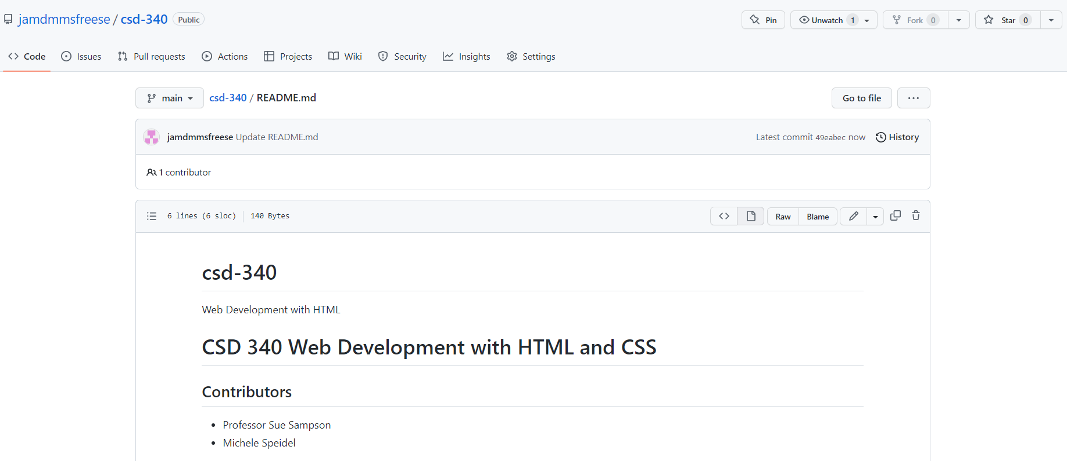

1. Screenshot of Local Directory

